Project: Todo App
Course: CSD 380: DevOps – Austen Rhyce Erickson
Description: UI Functional Test Plan
Date: 01/29/25

.

For each test, the developer should: provide a test description, a test objective, the developer name and date tested. For each step, fill out the actions to be taken and describe the expected results, and indicate yes or no for each step depending upon the result. The peer tester should provide their name, date tested, indicate yes or no for each step depending upon the result, and a screenshot (thumbnail) of the result.

Test 1 | “Add Task” button is activated after 4 chars entered in input field
 | Test Objective:  Prevent users from submitting a task without entering a todo item | Developer:  Date tested: 01/29/25 | Peer tester: Roald Medendorp  Date tested: 2025/1/30
Step | Action | Expected results: | Developer pass/fail | Tester pass/fail
1 | Open Todo app home page in browser | home page loads successfully | yes | 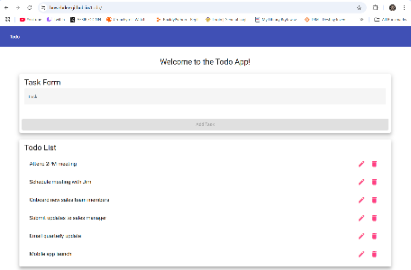yes
2 | Click into Task Form | Pink cursor is activated/appears | yes | no
3 | Type three char | “Add Task” button remains grey/non-clickable | yes | 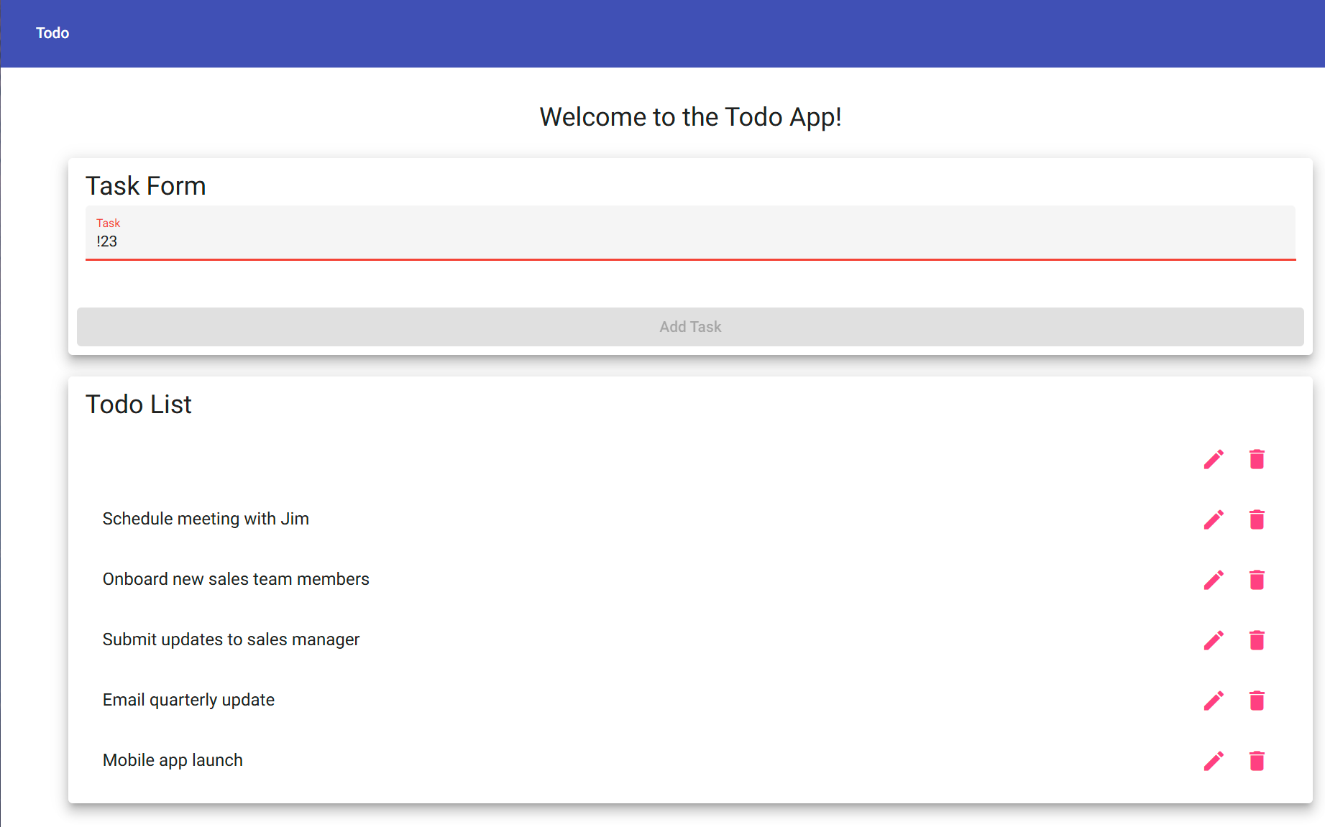yes
4 | Type fourth char | “Add Task” turns blue and can be clicked | yes | 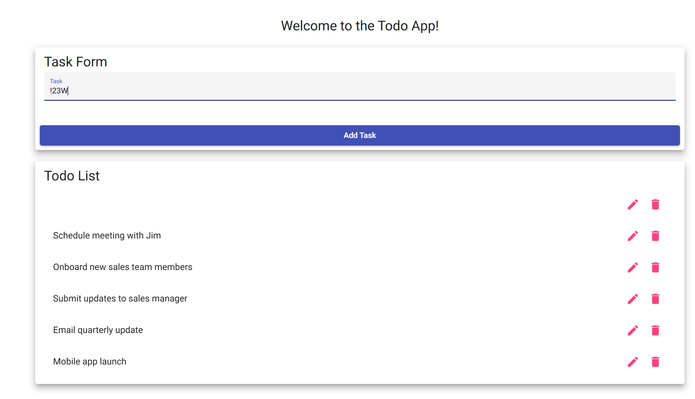yes
5 | Remove fourth char | “Add Task” returns to grey and cannot be clicked | yes | yes
Comments | Everything worked, but no pink cursor was found on my end.

Test 2 | In Edit Form, “Save” button is clickable only if there is a string present
 | Test Objective: Prevent users from submitting the edit form without entering a todo item | Developer:  Date tested: 01/29/25 | Peer tester: Roald Medendorp  Date tested: 2025/1/30
Step | Action | Expected results: | Developer pass/fail | Tester pass/fail
1 | Open Todo app home page in browser | home page loads successfully | yes | 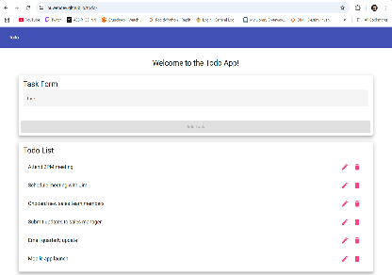yes
2 | Click into Edit Form of a task | “Save” button is pink and clickable | yes | 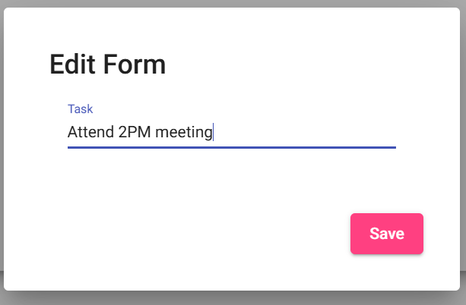yes
3 | String is cleared, input is empty | “Save” button turns grey/non-clickable | no | 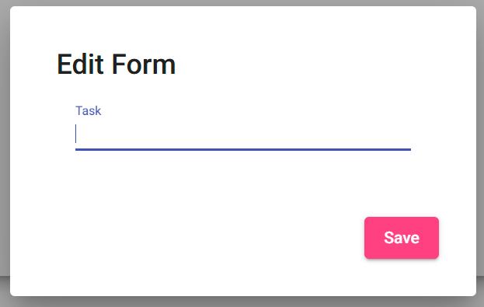no
4 | Chars are returned to input string | “Save” button returns to pink/clickable | no | no
Comments | Everything loaded without issues. The save button would not turn grey when information was missing.

Test 3 | Web app is responsive for mobile screens
 | Test Objective:  Provide users with a view for mobile devices | Developer:  Date tested: 01/29/25 | Peer tester: Roald Medendorp  Date tested: 2025/1/30
Step | Action | Expected results: | Developer pass/fail | Tester pass/fail
1 | Open Todo app home page in browser | home page loads successfully | yes | 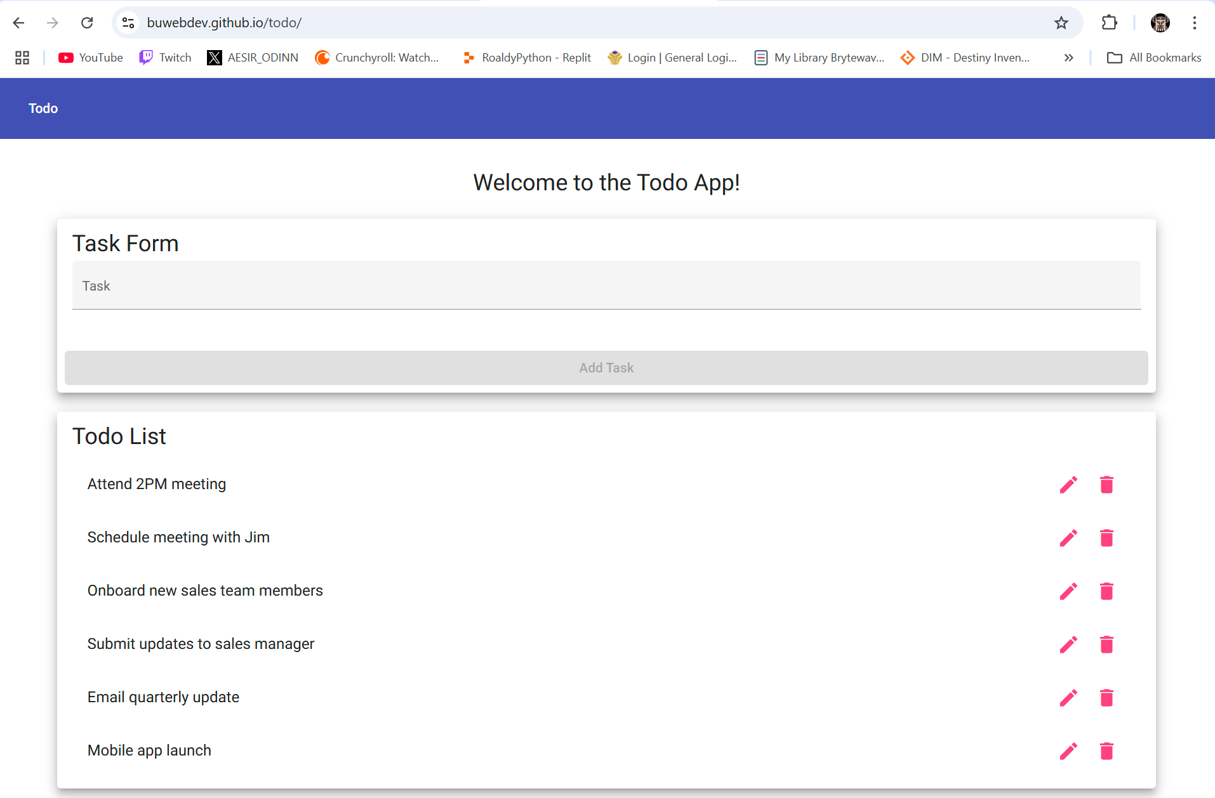yes
2 | Open iPhone SE view in developer tools | home page responds successfully to iPhone view and is still functional | yes | no
3 | Open Pixel 7 view in developer tools | home page responds successfully to Pixel 7 view and is still functional | yes | no
4 | Open Samsung Galaxy view in developer tools | home page responds successfully to Galaxy views and is still functional | yes | no
Comments | Unfortunately, the tester does not own any of these devices.

Test 4 | Web app is responsive for tablet screens
 | Test Objective:  Provide users with a view for tablet devices | Developer:  Date tested: 01/29/25 | Peer tester: Roald Medendorp  Date tested: 2025/1/30
Step | Action | Expected results: | Developer pass/fail | Tester pass/fail
1 | Open Todo app home page in browser | home page loads successfully | yes | yes
2 | Open iPad Air view in developer tools | home page responds successfully to iPad view and is still functional | yes | no
3 | Open Surface Pro 7 view in developer tools | home page responds successfully to Surface pro view and is still functional | yes | no
Comments | Tester does not have the following devices. Recommending to generalize smart devices in testing.

Test 5 | Web app returns custom message on 404 response
 | Test Objective:  For invalid URLs, provide user with custom 404 error page | Developer:  Date tested: 01/29/25 | Peer tester: Roald Medendorp  Date tested: 2025/1/30
Step | Action | Expected results: | Developer pass/fail | Tester pass/fail
1 | Open Todo app home page in browser | home page loads successfully | yes | yes
2 | Add “helloWorld” at end of URL in browser so it looks like this: https://buwebdev.github.io/todo/helloWorld | Page is redirected to this url:  https://buwebdev.github.io/todo/not-found  and a custom message is displayed, should read “not-found works!” | yes | 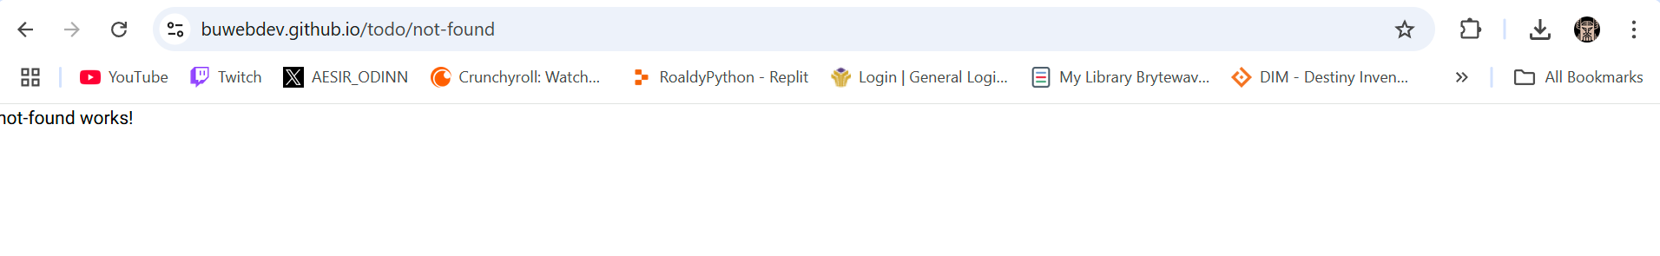yes

